# August Robotics - Lease Model Support Handbook

Welcome to the August Robotics Support Handbook. As a member of the support team, it is our responsibility to ensure our Lease Clients have a great experience every time they use their Lionel system. It is not uncommon for them to run into issues when operating the robots - some of these issues may be caused by human error, or system error. Being on the support team means you are able to identify the issue and provide advice to solve the issue. Being on support doesn't mean you have to stare at live client deployments all day, but it does mean you need to be attentive to support requests / emails / messages that come through - and reply to these requests as **quickly as possible**.

# Table of Contents

Common Tools for Support 1

Requirements for Support - UPDATE LINKS! 1

Support Schedule - Updated 08 Nov 2023 2

Shenzhen Office 2

Germany / UK Office 2

US Office 2

I'm on support today - What now? 3

Support Troubleshooting Guidelines 4

1. Identify the problem symptoms 4

2. Attempt to match the issue to our list of common issues 4

3. If the cause of issue is still unknown 5

4. Knowing when to escalate a problem 5

Things to consider when being on support 5

Speed / timing of replies 5

Language / tone of our replies 5

Quality of our Replies 6

Access to Information 6

Appendix 7

Setting up Remote Access 7

Setting up Tawk.to 8

Using Tawk.to to Provide Support 8

Grabbing logs / marking images from a Remote Device 10

Grabbing logs from an MSP using terminal 10

Grabbing logs from a Lionel using terminal 10

Locations of Logs / Mark images 11

**Support Map Processing 12**

Adding a Venue 12

Adding a Map 13

Making Changes 14

## Common Tools for Support

* [Tawk.to Helpdesk](https://dashboard.tawk.to/#/dashboard/)
* [Client Portal](https://portal.augustrobotics.com/)
* [Troubleshooting Guide](https://docs.google.com/spreadsheets/d/1M3LNGsa7ExcvZwHijmZDyPKyFrH6f0p7Khq7phSARbo/edit?usp=sharing)
* Support Schedule
* [Client Training Slides](https://augustrobotics.info/index.php/f/1065368)

## Requirements for Support *- UPDATE LINKS!*

To ensure that we provide the absolute best experience to the clients, you, as an operator need to make sure the following requirements are met:

* You are aware of the support schedule, and which days you are on support. Any changes to the support schedule will be broadcast on Ding.
* Your PC has remote access installed (v2ray, Tailscale, Wireguard), and you know how to use each of these tools.
* You have read and studied the most recent set of [client training slides](https://augustrobotics.info/index.php/f/1065368), and are aware of how to operate the system yourself.
* You have also made yourself familiar with the [Lease Model Troubleshooting Table](https://docs.google.com/spreadsheets/d/1M3LNGsa7ExcvZwHijmZDyPKyFrH6f0p7Khq7phSARbo/edit?usp=sharing) and how to use it.
* You have completed and passed the Support Competency Exam (WIP)
* You have been added to the [tawk.to](https://dashboard.tawk.to/#/dashboard/) helpdesk, and have read through the Guide on how to use the helpdesk.
* You are a superuser on the [Client Portal](https://portal.augustrobotics.com/), so that you have access to view / edit all client maps.
* You are able to parse maps on the [Client Portal](https://portal.augustrobotics.com/) and identify maps that are incorrectly parsed.

*If you cannot access any of the above, or have gaps in your knowledge about the system, please contact Tyron*

## 

## Support Schedule - Updated 08 Nov 2023

In the tables below, you will find the current support schedules for each office. **NB!** If you are on support, you take ownership of the outcome of that day.

### Shenzhen Office

| **Day** | **Person** | **Hours (Local times)** |
| --- | --- | --- |
| Monday | Leo | 09:00-17:00 |
| Tuesday | Jiancheng | 09:00-17:00 |
| Wednesday | Frank | 09:00-17:00 |
| Thursday | Tang | 09:00-17:00 |
| Friday | Patrick | 09:00-17:00 |
| Saturday | - | - |
| Sunday | - | - |

### Germany / UK Office

| **Day** | **Person** | **Hours (Local times)** |
| --- | --- | --- |
| Monday | Jack | 09:00-17:00 |
| Tuesday | Jordan | 09:00-17:00 |
| Wednesday | Georgios | 09:00-17:00 |
| Thursday | Michael | 09:00-17:00 |
| Friday | Tyron | 09:00-17:00 |
| Saturday | - | - |
| Sunday | - | - |

### US Office

| **Day** | **Person** | **Hours (Local times)** |
| --- | --- | --- |
| Monday | Marshal | 09:00-17:00 |
| Tuesday | Athrav | 09:00-17:00 |
| Wednesday | Nyoko | 09:00-17:00 |
| Thursday | Athrav | 09:00-17:00 |
| Friday | Marshal | 09:00-17:00 |
| Saturday | - | - |
| Sunday | - | - |

The calendars for the support schedules are stored on NextCloud, you can add these calendars to your email client or personal calendar app using the following links:

* [Asia](https://augustrobotics.info/remote.php/dav/calendars/tyronjardine/client-support-schedule/)
* [Europe](https://augustrobotics.info/remote.php/dav/calendars/tyronjardine/support-schedule-eu/)
* [US](https://augustrobotics.info/remote.php/dav/calendars/tyronjardine/support-schedule-us/)

The calendar for scheduled client deployments is also stored on NextCloud. This calendar intends to give us warnings of upcoming client deployments, however, this is not a good indication of any last minute deployments.

* [Client Deployments](https://augustrobotics.info/remote.php/dav/calendars/tyronjardine/client-deployments_shared_by_portalsite/)

*If you cannot access these calendars, please ask the schedule owner (Tyron) to add you to the calendar.*

**If you cannot be on support - due to annual leave, sick leave, sitework etc. It is your responsibility to get the shift covered!**

For example, Leo has annual leave booked for Monday, he can ask any of the other members of the Shenzhen support team to cover this day.

If for example, Jay and Hongwei decide that they want to swap days, this is fine, **however,** if it's a **permanent** swap, please notify the schedule owner (Tyron). If it is a **once off** swap, please make sure it is also reported.

## I'm on support today - What now?

In order to provide the best support for clients, we have a variety of ways in which they can get in touch with us:

* They can send an **email** to [support@augustrobotics.com](mailto:support@augustrobotics.com).
* They can use the “**live chat**” feature on the GUI, which goes to our [tawk.to](https://dashboard.tawk.to/#/dashboard/) helpdesk.
* They can **email** or **phone** their AR representative directly (although we should not encourage this in the long term)

This means that when you start your support shift, you need to make sure you have 100% access to your August Robotics **emails**, **AND** are logged into the [tawk.to](https://dashboard.tawk.to/#/dashboard/) **helpdesk**. Support requests received by AR representatives will also be forwarded to you.

Additionally, we can **proactively** look for client issues using the following tools:

* The DingTalk group “**Remote Access**” lets us know when client devices are powered on.
* The DingTalk group “**Boothbot Alert**” tells us when equipment has encountered an error.
* On the [Client Portal](https://portal.augustrobotics.com/), we can check the “**Remote Monitoring**” page to see the state of all online devices.

## Support Troubleshooting Guidelines

One of the most difficult things to do while on support is to identify the root cause of a problem. Often, we are helping clients very far away, without being able to see the equipment. In many situations, remote access is our best tool. By using remote access, we can effectively “see” what the client sees - at least on their tablet. We can also perform a deeper analysis on certain issues by viewing the logs. However, remote access, and checking logs is not always the solution, and often we need to consider various factors to solve a problem.

### Identify the problem symptoms

The first step of solving a problem is to identify exactly what the problem is. Often, we will need to ask the client a few questions to get a better understanding, and narrow down the problem area. Some of these questions could include:

* Is this the first time this issue has occurred?
* How often does this issue occur?
* Did the user do anything specific to get the problem to occur?
* Has the user restarted any equipment?

### Attempt to match the issue to our list of [common issues](https://docs.google.com/spreadsheets/d/1M3LNGsa7ExcvZwHijmZDyPKyFrH6f0p7Khq7phSARbo/edit?usp=sharing)

Once we have asked a few questions, and narrowed down the issue, we should check our table of common troubleshooting steps. Many client issues of the past have been tracked, evaluated and stored in this table. There is no need to try to re-invent a solution if we already have them.

### If the cause of issue is still unknown

If the issue is still not solved, we need to attempt to identify the cause. Sometimes the cause can be separated into **hardware** or **software.** But the problems are not always clear.

Depending on the problem, we need to determine a possible approach for the solution. Some possible approaches we have are:

* Asking the user to reboot problematic devices
* Using remote access to view the MSP GUI
* Using remote access to view the logs of the MSP / Robot

If for example, their robot's nozzle is blocked, and they aren't sure what to do - it would be silly to use remote access to assist them. In a situation like this, we need to provide steps that deal with the problem at the source, such as checking the bottle connection, checking that the pump is working, replacing the nozzle etc.

### Knowing when to escalate a problem

As a member of support - you are not alone. Ideally, each member of support should be capable of solving 95% of issues clients face. There will always be undiscovered issues or new scenarios. It's important to know when to escalate a problem to the broader support team. Escalate a problem when:

* No solution has been found within ~15 minutes
* None of the steps in the [troubleshooting table](https://docs.google.com/spreadsheets/d/1M3LNGsa7ExcvZwHijmZDyPKyFrH6f0p7Khq7phSARbo/edit?usp=sharing) have worked
* You have tried alternative solutions, that have not worked

## Things to consider when being on support

### Speed / timing of replies

Slow replies are going to leave customers frustrated, stuck, and potentially unable to finish a markout. It is extremely important that we are quick to respond to clients. Support requests that are delayed or unanswered can cause customers to rethink their use of our product. An absolute worst case scenario.

### Language / tone of our replies

As a company, we have an extremely international team. We speak many different **languages** - and so do our clients. Most of our clients will be able to communicate in English. Perfect English is not expected from you! For many of us, English is our second or third language. It might be important to make the client aware of this - a quick **introductory message** will go a long way. For example:

“Hi Mr ****,

Thank you for your message, my name is Leo, I am part of the August Robotics team in Shenzhen. I am here to assist you with your issue.

Please note - English is not my first language, but I will try my best to communicate clearly.”

Additionally, we need to ensure we are as **respectful** as possible to the client. Many of our clients are not **technically skilled**, so something that may seem simple to us as engineers might be very difficult to understand for them. We need to exercise **patience** when trying to get information about a problem from the clients.

### Quality of our Replies

When we reply to clients about issues they are having, we need to think about the quality of reply we are giving. Short answers may not be a good way of communicating. We should try to provide as much detail as possible - it's sometimes a good idea to pretend the client has never seen the system before.

### Access to Information

As a member of support, we have a vast amount of access to information about the system and how it works. Do not try to solve all problems from memory! Please make use of the information at hand.

## Appendix

### Setting up Remote Access

| *Please see the latest guide on Gittee for remote access if this is outdated:* | <https://e.gitee.com/august-robotics/projects/252558/repos/boothbot/boothbot-ansible-v3/blob/master/remote_access_guide.md> |
| --- | --- |
| *All of these steps assume the user is on Windows! If you want to use Linux, please see the gitee link* |  |
|  |  |
| **Using v2ray (Only for SSH):** | Download the following Alias file - [alias](https://drive.google.com/file/d/1CoI6lUXIN-WoZ7X_otmYe4hc0OeDTuNa/view?usp=drive_link) |
| Place the alias file in your C:\Users\Username folder |
| Make sure you are using "Git Bash" for command line |
| Edit the file C:\Users\Username\.bashrc |
| Add the line "source alias" |
| Restart Git Bash |
| Connect using "R Lxxx 00xx" |
|  |  |
| **Using Tailscale (SSH and GUI access):** | Download and install tailscale - [https://tailscale.com/kb/1022/install-windows/](https://gitee.com/link?target=https%3A%2F%2Ftailscale.com%2Fkb%2F1022%2Finstall-windows%2F) |
| Run the following in Windows Powershell "tailscale up --login-server=https://remote1.augustrobotics.com:443 --reset --force-reauth" |
| The command should print out a local web link, please open it by click or copy it to the browser. |
| The browser should display a command, which should be run on the server, please send this command to Hongwei and keep the window open |
| After Hongwei has run the command, your pc should connect to the Tailscale network. |
| Connect using "ssh augbooth@<DEVICE NAME>.ts.augustrobotics.com" |
| GUI can be accessed by going to: "http://<DEVICE-NAME>.ts.augustrobotics.com/ |
| Everytime when using (if not default connected), make sure to run above: in Windows Powershell "tailscale up --login-server=https://remote1.augustrobotics.com:443 --reset --force-reauth" |
|  |  |
| **Using Wireguard (SSH and GUI access):** | Currently no setup instructions for Windows, see gitee for Linux setup. |

### Setting up [Tawk.to](https://dashboard.tawk.to/#/dashboard/)

1. To set-up tawk.to, you need to have received an email invite from the helpdesk manager. If you have not yet received this, please get in touch with Tyron, Leo, Jack, Marshal or Patrick.
2. Once you have received an invite, you will be asked to create an account.
3. Once the account is created, you will arrive at the dashboard. Please “Allow” notifications if prompted, and bookmark this page so it is easier to access in the future.

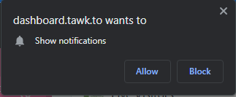

1. It is recommended that you take the tour through the dashboard.It will explain the functionality of tawk.to, and how to use it.

### Using [Tawk.to](https://dashboard.tawk.to/#/dashboard/) to Provide Support

Once you are set up on the platform, you are ready to learn how to use it. When you log in, you will arrive at the dashboard. At a glance, the dashboard shows:

* New chat requests
* Live visitors on our support line
* Chat histories

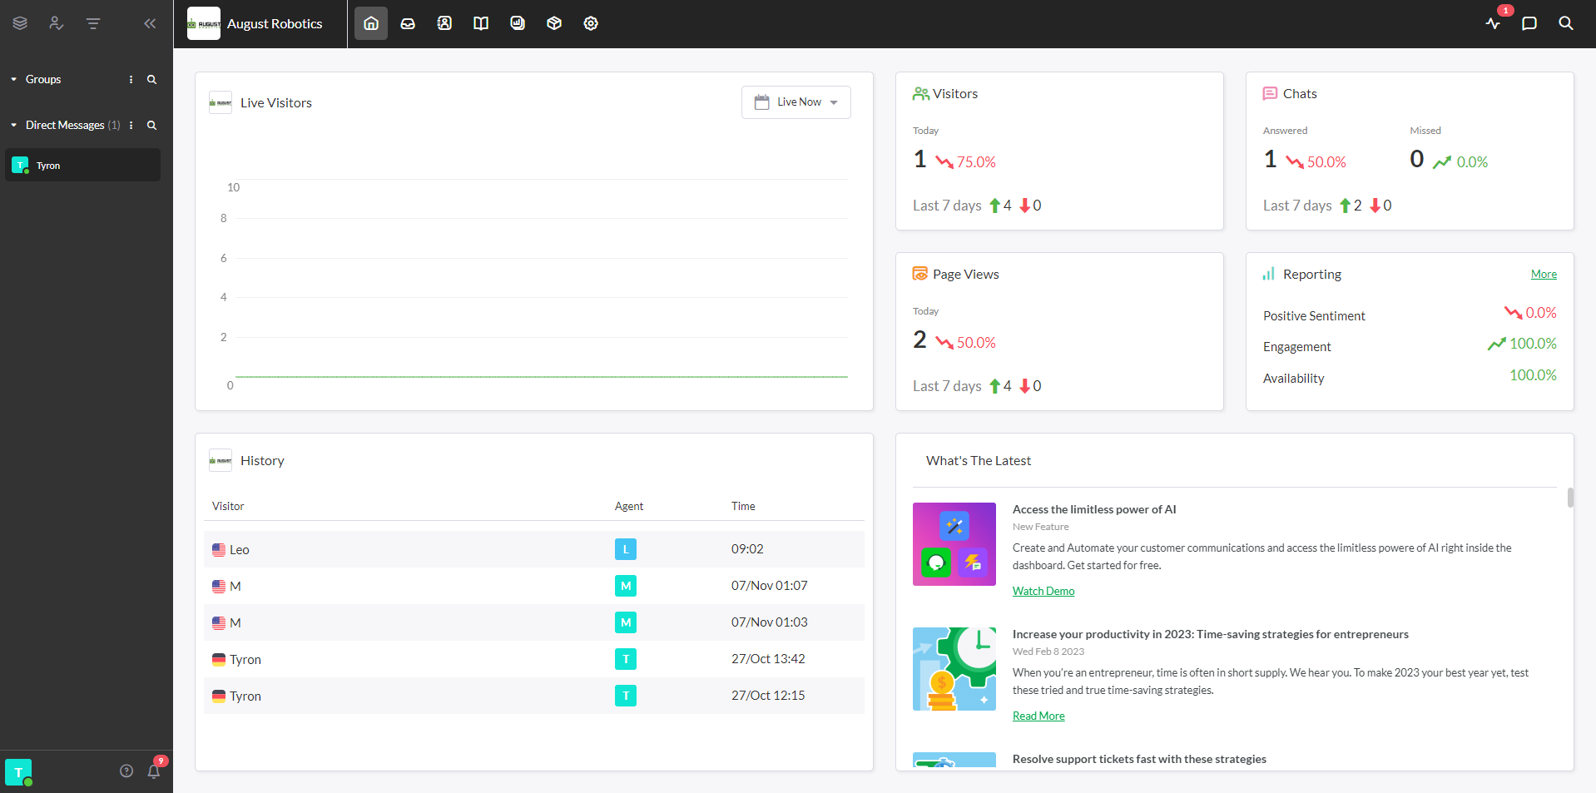

From the dashboard, we can also access incoming chat requests, which will come up at the top left. **NB!** This means someone is asking for help!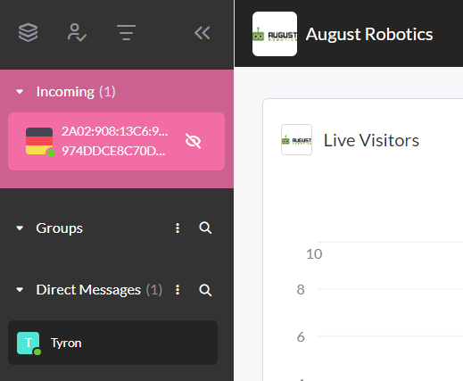

If the notification is clicked, it allows you to join the chat and assist the client. 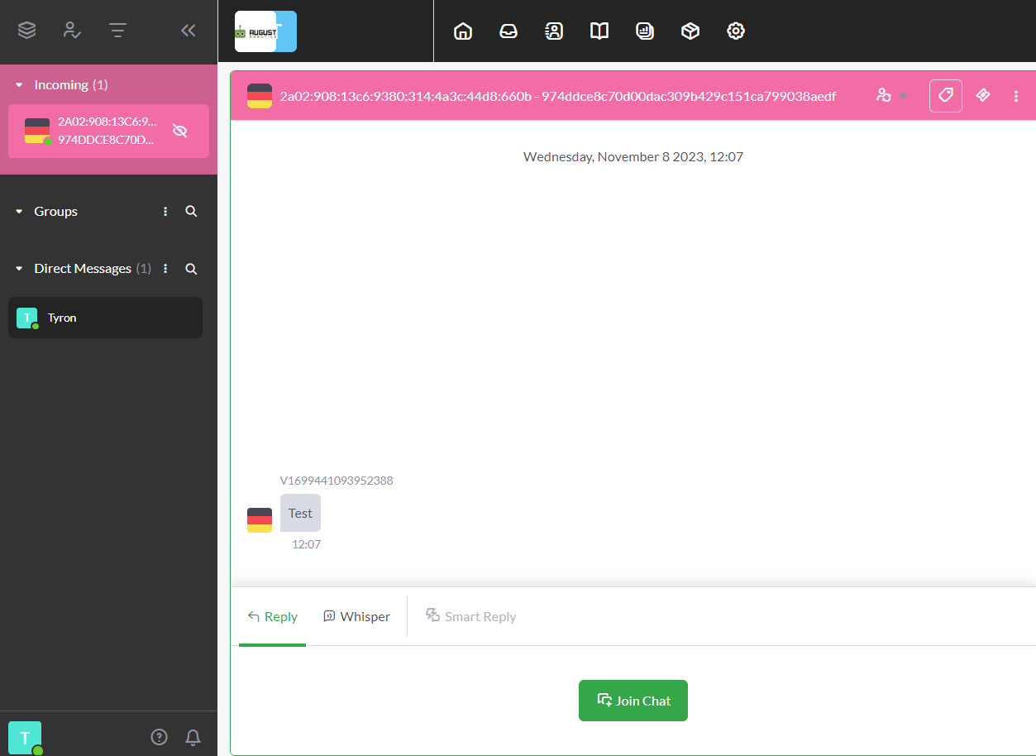

If the user is indeed having issues, we should create a ticket, describing the issue in as much detail as possible, the severity, and adding any attachments that may be needed.

Please see the following resources for using Tawk.to - provided by the website help centre:

* <https://help.tawk.to/>
* <https://help.tawk.to/category/dashboard-101>
* <https://help.tawk.to/category/getting-started>
* <https://help.tawk.to/category/ticketing>
* <https://help.tawk.to/category/advanced-features>
* <https://help.tawk.to/category/chat-widget-customization>

*\*Note, some of these topics will come up in the* ***Support Competency Exam***

### Grabbing logs / marking images from a Remote Device

One of the easiest ways we can grab logs from a remote device, is using [WinSCP](https://winscp.net/eng/download.php) (On Windows). It's as easy as inputting the MSP details and connecting from there. 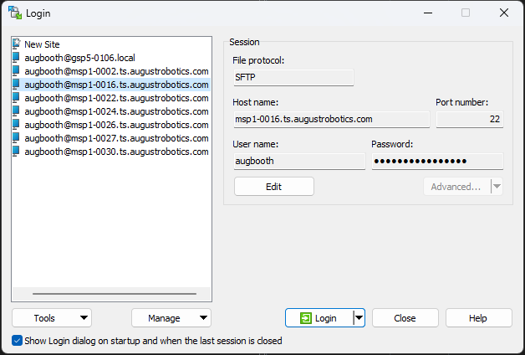

#### Grabbing logs from an MSP using terminal

If we want to grab the logs from an MSP remotely, the next easiest way is to use “scp”. For example, we need to grab some logs from MSP16. We can do the following on YOUR PC:

**scp augbooth@msp:/msp_directory /your_pc_directory**

For example:

**scp augbooth@MSP1-0016.ts.augustrobotics.com:~catkin_ws/local/roslog/latest/* /Downloads/MSP1-0016Logs/**

*I would recommend* [*zipping*](https://www.cyberciti.biz/faq/how-to-tar-a-file-in-linux-using-command-line/) *the files before using scp.*

#### Grabbing logs from a Lionel using terminal

To grab the logs from a Lionel, we first need to get them onto the MSP with internet access. The same process as above applies, first we should do the following on the MSP:

**scp augbooth@lionel:/lionel_directory /msp_directory**

Once the files have been copied to the MSP, we can SCP them onto our laptop.

*I would recommend* [*zipping*](https://www.cyberciti.biz/faq/how-to-tar-a-file-in-linux-using-command-line/) *the files before using scp.*

### Locations of Logs / Mark images

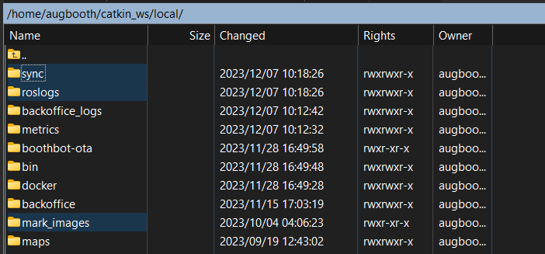

* Sync - contains all the older logs, packed away everytime the robot boots
* Roslog - contains all the latest ROSLOGS
* Mark images / images - contains all the marking images on the device

## 

### Support Map Processing

The User portal is what the client will use usually in the office, before taking all of their equipment to the hall. In the context of support, we should know how to help them with their maps if they have made a mistake during the processing step. .

**Client Portal URL:** [https://portal.augustrobotics.com](https://portal.augustrobotics.com/)

The purpose of the client user portal is to:

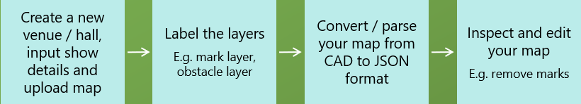

*As an August Support team member, you will have super-user access to the client portal, which enables you to see all clients maps.* ***Be aware****, When uploading a map on a client’s behalf, if you select the wrong client, this could result in the client viewing another client’s data, which is a* ***serious data breach****.*

### 

#### Adding a Venue

A client may request for a hall to be added for them. To do this, from the Map list page, follow these steps:

* Click the 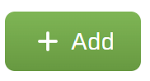 button in the top right
* Click 
* The following inputs will appear. Ensure relevant information is filled correctly, and the WxH(m) measurements are accurate. This information can be obtained from the CAD template. 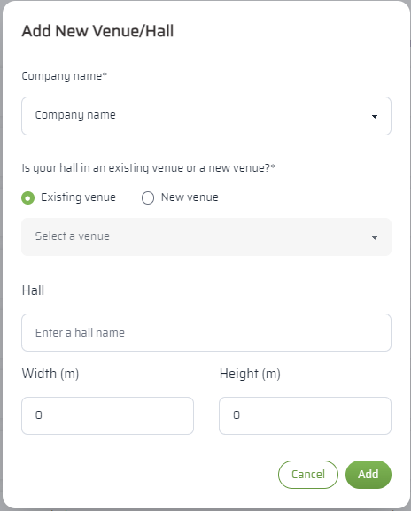

## 

#### Adding a Map

* Click the  button in the top right
* Click 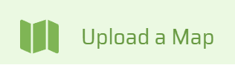
* The following will appear , please input the required details: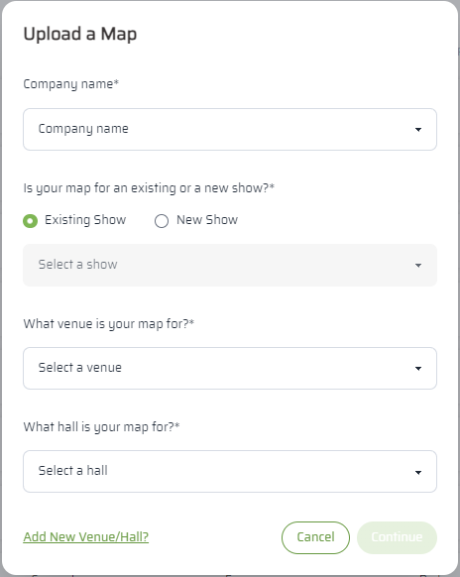
* Next we have to choose the correct DXF 2007 file to process. 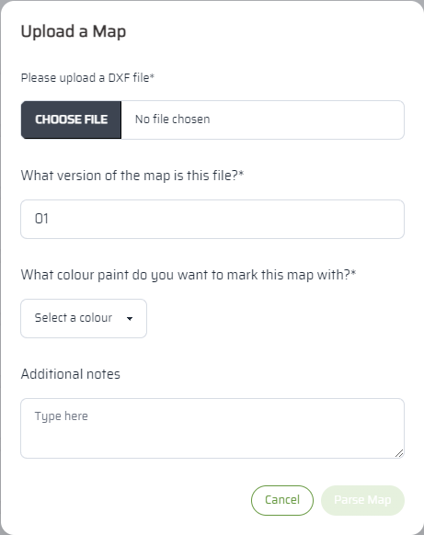
* Always ensure the target layout is Model.
* The next window will appear. The clients AR representative should have set the appropriately named layers during training week. If so, this section will auto-populate **aside from the layers containing marks.**

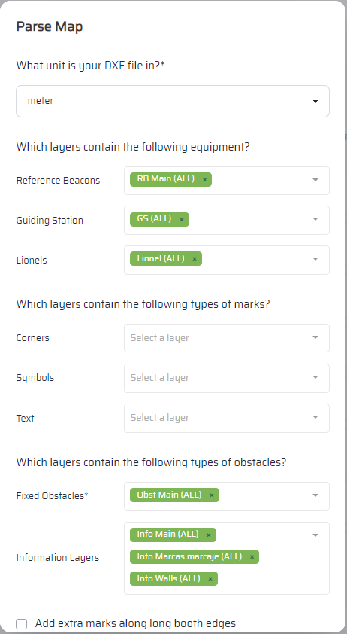

*Note: DXF unit section is a common introductory point for errors, ensure the unit matches the DXF! If the map does not size to screen on the preview page, this is a likely cause. Avoid parsing unnecessary layers, this reduces GUI speed.*

#### Making Changes

In the Map List section, you can view uploaded maps, and navigate from here to make changes.



* Click the “View” or “Edit”  icons to review (Opens the screen below)
*  Upload a new DXF file (usually used if booth layouts have changed), or
*  Re-parse the current DXF file (usually used if you made a mistake in selecting layers)

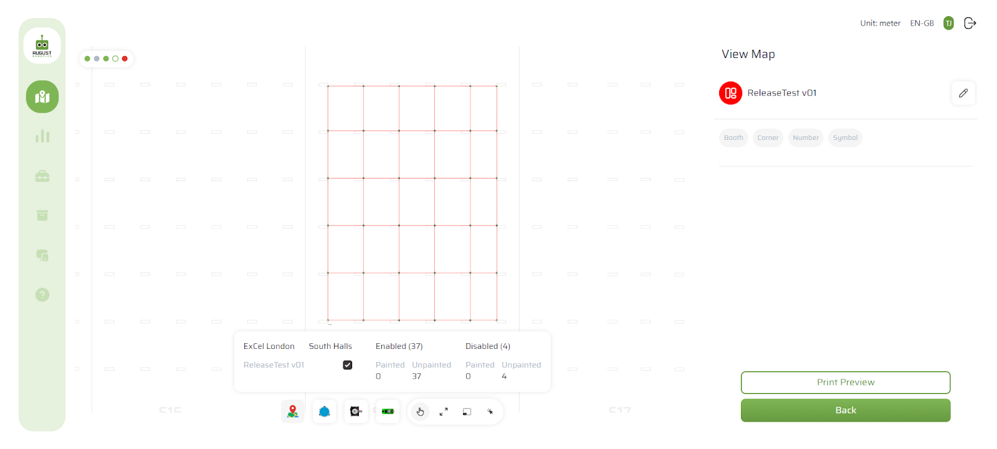

* When this is selected, the user can zoom in/out and move around the map*

*When this is selected, the view will be reset to the initial view*

*When this is selected, the user can drag or click to select marks and obstacles*